SetupDashboardPage
When you open the dashboard, SetupDashboardPage sets the initial slider values,
and fills in the initial values for the savings to date and the payback end-date.
It calls CalcSavingsToNowFromBills to get the savings from the difference between utility bills and PC bills from the contract start date up until “now”, in dollars, kwh and btus.
It calls CalcAnnualSavingsByCddHddBase to calculate the annual estimated savings for the future in dollars, kwh and btus.
It calls calcPaybackDate, which uses the past savings. It calculates the payback time and adds it to today to get the payback date.

calcPaybackDate(Financial finances, Integer savingsPreviousElectric, Integer savingsPreviousGas, Integer savingsPreviousDollars, Integer annualElectricSavings, Integer annualGasSavings, Integer dollarSavings)
Get savings for a before “now”, which should have resulted from adding savings calculated from the difference between PC bills and utility bills (SavingsToDate). Then calculate the payback date as the date when the annual expenses + past expenses == annual savings + past savings.
// calculations below
savingsToDate = savingsPreviousDollars;
savingsAnnualFloat = (annualElectricSavings) * finances.getPricePerKWh() + (annualGasSavings) * finances.getPricePerBTU();
expAnnual = finances.getAnnualExpense();
extraYearsFloat = ((float) expToDate - (float) savingsToDate) / (savingsAnnualFloat - (float) expAnnual);
extraDays = (int) (extraYearsFloat * 365.0);

CalcAnnualSavingsByCddHddBase:
Calculate the predicted typical annual savings, with weather for a typical year, for an enterprise. For each building/site, add up expected lighting savings, heating savings (occupied and unoccupied), and cooling savings ( occupied and unoccupied). This calls weatherManager.GetHDD and weatherManager.GetCDD to calculate the annual HDD / CDD required to maintain the specified setpoints.
The following pair of function calls calculates the estimated annual cooling degree days of the original specified setpoint (HeatVal) vs. the most recently stored setpoint (client.getSetpointCoolOcc).
origCddOccAnnual = weatherManager.GetCDD(client.getOrigSetpointCoolOcc() - gBaseDiffOcc, weatherstation);
newCddOccAnnual = weatherManager.GetCDD(client.getSetpointCoolOcc() - gBaseDiffOcc, weatherstation);
There are similar pairs of calculations for each other key value, such as occupied and unoccupied cooling setpoints and lighting.
These are multiplied by the corresponding percentage, then differenced.
oldCoolOccKwhAnnual = Math.round(oldKwhPerCdd * origCddOccAnnual * percentOcc);
newCoolOccKwhAnnual = Math.round(newKwhPerCdd * newCddOccAnnual * percentOcc);
savedkWHAnnual += (oldCoolOccKwhAnnual - newCoolOccKwhAnnual) + (oldCoolUnoccKwhAnnual - newCoolUnoccKwhAnnual) + (oldOtherKwhAnnual - newOtherKwhAnnual) + (oldLightingKwhAnnual - newLightingKwhAnnual);
This is done for each site/building for the enterprise.
For dollar calculations, multiply resource savings by resource cost.
moneySavedAnnual = (int) (savedkWHAnnual * pricePerKwh + savedBTUAnnual * pricePerBtu);

RecalculatePaybackScenarioByBuilding
This is called when the user changes a slider for a building in the scenario page.
It grabs the appropriate settings for the building/site from the sliders.
Tally the 'additional' money saved due to the changes in building specific scenario settings.
e.g.,
electricitySavings -= GetEnergyChangeAfterIncrementLighting(LightVal, site, schedule);
It calculates the incremental savings...
Integer predictedMoneySaved = (int) (finances.getPricePerBTU() * gasSavings);
predictedMoneySaved += (int) (finances.getPricePerKWh() * electricitySavings);

Calculate the Savings up to “now” From utility & PC Bills [CalcSavingsToNowFromBills]
Calculate the predicted annual gas & electric savings based on the building “energy models” and typical annual weather HDD/CDD.
Then it adds the new incremental savings to the predicted money saved from the stored setpoints, and it calculates the new payback period.
Date paybackDate = calcPaybackDate(finances, savedKWH, savedBTU, savedDollars, savedkWHAnnual, savedBTUAnnual, moneySavedAnnual);

RecalculateDashboardPaybackScenario:
This is called when the user changes a slider for the enterprise on the dashboard or on the scenario page.
It grabs the appropriate settings for the enterprise from the sliders.
Tally the 'additional' money saved due to the changes in enterprise scenario settings.
savingsList = CalcAnnualSavingsByCddHddAdditional(client, LightVal, CoolVal, HeatVal, CoolUOVal, HeatUOVal);
savingsList contains electric (kwh), gas (btu) and dollar savings.
It calculates the incremental savings...
Integer predictedMoneySaved = (int) (finances.getPricePerBTU() * gasSavings);
predictedMoneySaved += (int) (finances.getPricePerKWh() * electricitySavings);
Calculate the Savings up to “now” From utility & PC Bills
savingsList = CalcSavingsToNowFromBills(client);
Calculate the predicted annual gas & electric savings based on the building “energy models” and typical annual weather HDD/CDD.
savingsList = CalcAnnualSavingsByCddHddBase(client);
Then it adds the new incremental savings to the predicted money saved from the stored setpoints, and it calculates the new payback period.
Date paybackDate = calcPaybackDate(finances, savedKWH, savedBTU, savedDollars, savedkWHAnnual, savedBTUAnnual, moneySavedAnnual);

CalcSavingsToNowFromBills
Calculate the Savings up to “now” From utility & PC Bills
The “endDateBills” is assumed to be today's date.
PCBillsTotals and BillTotals go through all bills and tally the dollar amounts, kwh's, and btu's.
PCBillTotals = pcBillManager.sumBillsByClientIdFast(gClientId, startDateBills);
BillTotals = billManager.sumBillsByClientIdFast(gClientId, startDateBills);
Then the totals are differenced to get the savings... “Fake” refers to Performance Contractor totals.
savedDollars += (sumFakeDollars – sumDollars);
savedKWH += sumFakeKWH - sumKWH;
savedBTU += sumFakeBTU – sumBTU;

CalcAnnualSavingsByCddHddAdditional
This function calculates the estimated annual additional savings resulting from changes in slider values.
The following pair of function calls calculates the estimated annual heating degree days of the newly specified setpoint (HeatVal) vs. the stored setpoint (client.getSetpointHeatOcc).
origHddOccAnnual = weatherManager.GetHDD(client.getSetpointHeatOcc() - gBaseDiffOcc, weatherstation);
newHddOccAnnual = weatherManager.GetHDD(HeatVal - gBaseDiffOcc, weatherstation);
There are similar pairs of calculations for each other key value, such as occupied and unoccupied cooling setpoints and lighting.
These are multiplied by the corresponding percentage, then differenced.
oldHeatOccBTUAnnual = Math.round(newBtuPerHdd * origHddOccAnnual * percentOcc);
newHeatOccBTUAnnual = Math.round(newBtuPerHdd * newHddOccAnnual * percentOcc);
savedBTUAnnual += (oldHeatOccBTUAnnual - newHeatOccBTUAnnual) + (oldHeatUnoccBTUAnnual – newHeatUnoccBTUAnnual);
This is done for each site/building for the enterprise.
For dollar calculations, multiply resource savings by resource cost.
moneySavedAnnual = (int) (savedkWHAnnual * pricePerKwh + savedBTUAnnual * pricePerBtu);

weatherManager.GetHDD
// this returns the annual HDD for the weather station given a baseTemp
public Integer GetHDD(Integer newBaseTemp, Weatherstation station)
This function relies on data (annual HDD assuming a given base temperature, and the first and 2nd degree sensitivity of the HDD to the setpoint). These quantities are obtained separately from the website degreeday.net, which will generate a spreadsheet given a weather station and a base temperature. I have sample spreadsheets for Ann Arbor (KARB) on my other computer at Emag Tech. I'll try to remember to send them to you, otherwise ask. It's relatively easy to get the 1st and 2nd degree sensitivities from this.

SumBillsByClientIdFast (one for Bills, one for performance contractor bills, i.e. PCBills)
The utility bill version builds up queries to get all sites for an enterprise, and then to get all utility meters for those sites, and then to get all bills from the meters. The PCBills version doesn't need meters, it gets all bills from the sites. Then each sums the bills for KWH, BTU, and dollars.

SetPolicy
Grabs slider values, and stores them to the database for each site individually if the site doesn't override the enterprise, and for the enterprise as a whole.
energyManager.AddPartialEnergytoDb(energy.getIdEnergy(), energy.getIsOverride(), CoolVal, CoolUOVal, HeatVal, HeatUOVal, LightVal);
clientManager.updateClientPartial(gClientId, LightVal, HeatVal, HeatUOVal, CoolVal, CoolUOVal);
Then it generates and sends an email, from:
String from = "open.world.energy.web.tools.ad@gmail.com";
String pass = "openworld";
You can use the username and password above as an openworld energy account.

CalcSavingsToNowByCddHdd (not used)

Database...
Presently, the database password is b1024b.

Glassfish Server Settings:
as for installation, i don't know if there's any one page i used. Most of the hard work (installing java/glassfish in linux) was done by the host - the hosting environment came that way. I just had to ask them how to access the glassfish admin page to set up the connection pool/database/security and then used the admin page to deploy the WAR file (glassfish admin->applications->deploy). As long as the mysql database is set up correctly (including the mysqlconnector JAR) and the connection pool (and security) is correct, you should be set to go.

probably the easiest way is to reopen the hosting account that we initially used for this.
See the glassfish server settings below.

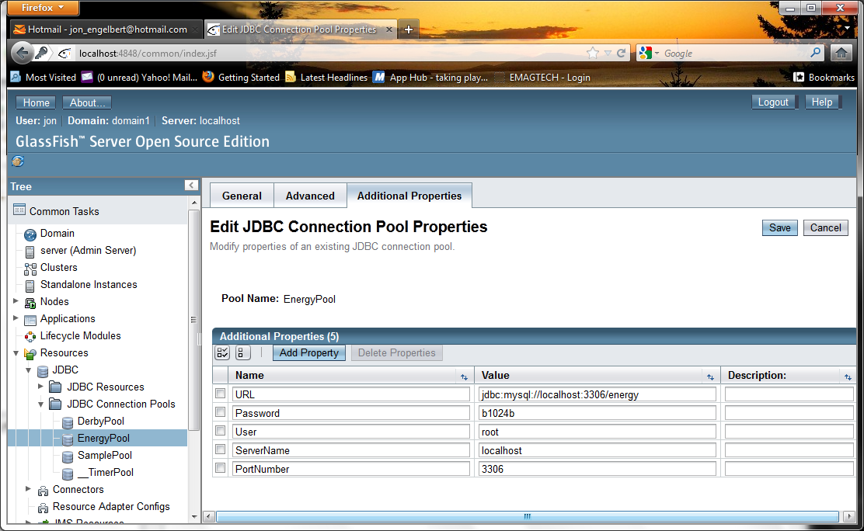

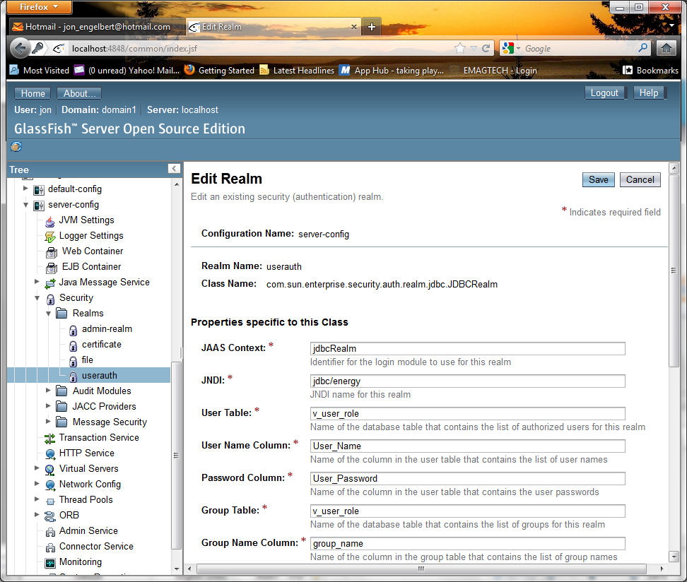

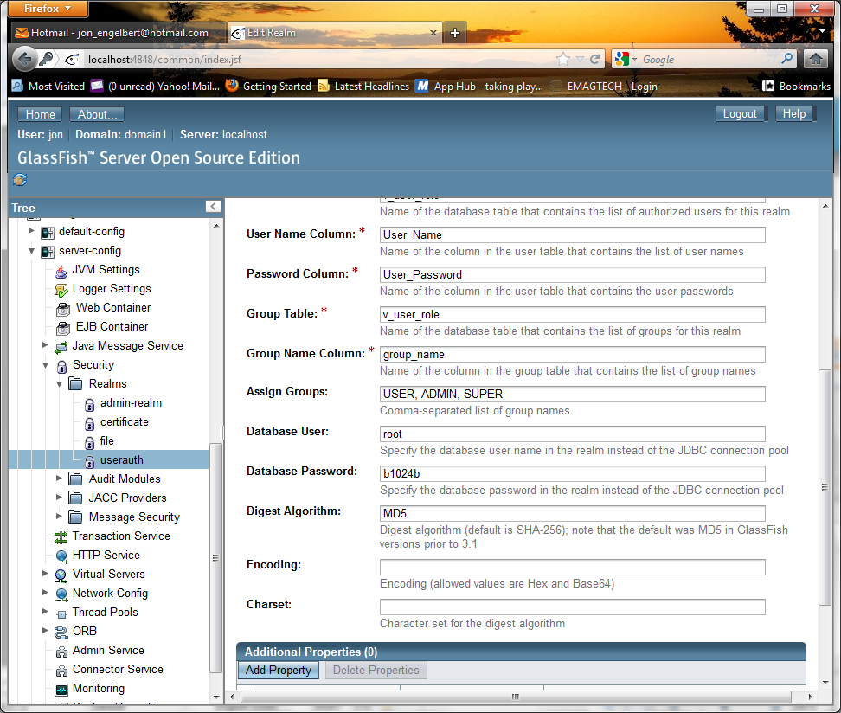
Former Oeapps web site:
Glassfish admin page:
http://www.openworldenergyapps.com:4848/
id: admin
pw: oe!2345

phpMyAdmin:
http://www.openworldenergyapps.com/myadmin/
id: root
pw: oe!2345

The pic below is the info to log into the “account” that controls the setup of the hosting package.
https://portal.eapps.com/index.php
Id: cnerys@openworldenergy.com
Pw: 12openworld34

To log into our server proper, go to https://68.169.48.50:10000
Login: root
Pw: oe!2345

The order confirmation number is 4368136720

You’ll get an email with the order details. If there are specific instructions on how we should proceed, could you please forward it to me? Thanks.

The info I used to sign up as a new customer is attached below:

